SANJIVANI UNIVERSITY

School of Engineering and Technology (SET)



MINI PROJECT
Academic Year: 2026-27

TITLE OF PROJECT:

Enterprise Student Record and Academic Management Platform

Subject: DevOps and Cloud Foundation (IBM) Subject code: 26UDSAE201
Course: Artificial Intelligence & Data Science Semester: 3
Name : Krushna Gorakh Dhamane PNR: 2126UDSM2574
TABLE OF CONTENTS

Sr. No. | Chapter / Documentation
1 | Business Problem Statement & Business Justification
2 | Business Requirements Document (BRD)
3 | Product Vision Document
4 | Stakeholder Analysis Report
5 | User Persona Report
6 | Functional Requirements Specification (FRS)
7 | Non-Functional Requirements Specification (NFRS)
8 | Design Thinking Report
9 | IBM Design Thinking Report
10 | IBM Loop Documentation
11 | Minimum Viable Product (MVP) Definition
12 | Product Roadmap
13 | Initial System Architecture
14 | Project Charter
15 | Product Discovery Documentation
16 | Project Repository Initialization
17 | Project Folder Structure
18 | Conclusion

Business Problem Statement & Business Justification

1.1 Background
Higher education institutions handle large volumes of student and academic data — registrations, programs, subjects, attendance, examinations, marks, results and academic reports. In many institutions this information still lives across separate registers, spreadsheets and administrative processes, which makes it hard for students, faculty and administrators to access and manage academic information efficiently.
Good software product engineering practice calls for understanding the business domain, its users and their requirements before implementation begins. This document therefore starts by examining the academic management process and the problems faced by each stakeholder group, before moving into design and technical planning.

1.2 Business Problem Statement
Students and academic staff need a centralized, reliable and user-friendly system for managing student records and academic information. When these records are handled through fragmented or manual processes, institutions typically encounter:
- Difficulty accessing academic information quickly
- Repetitive data entry across multiple registers
- Delays in preparing academic reports
- Inconsistent or duplicated student records
- Limited visibility for academic administrators
- Difficulty tracking attendance and examination data
- A higher risk of data-entry errors
- Delays in giving students timely academic information
A centralized Enterprise Student Record and Academic Management Platform is proposed to address these problems.

1.3 Problems to Be Addressed
Student problems - Academic information is not available from a single place - Attendance information may not be immediately visible - Students depend on faculty or administration for basic records - Accessing results and reports often requires a manual request
Faculty problems - Repetitive attendance and marks entry - Difficulty managing records for large student cohorts - Time lost maintaining information across multiple files - Extra manual effort to compile academic information
Administrator problems - Managing large volumes of student records - Keeping academic information accurate and current - Compiling reports from disconnected sources - Managing user access alongside academic data
Examination cell problems - Managing examination and marks data - Maintaining result-related records - Preparing academic reports - Keeping examination records consistent with student records

1.4 Proposed Solution
The proposed platform will centralize the following capabilities:
- Student registration and profile management
- Academic structure management
- Attendance management
- Examination management
- Marks management
- Result management
- Academic report generation
- Role-based access control
- Administrative management

1.5 Business Justification
Area | Existing Challenge | Proposed Solution
Student Records | Distributed across registers | Centralized student records
Attendance | Manual, repetitive process | Digital attendance management
Examination | Kept in separate records | Centralized examination management
Results | Manually processed and reported | Structured result management
Administration | Limited centralized visibility | Administrative dashboard
Data Quality | Risk of inconsistent records | Validation and database constraints
Reports | Repetitive manual preparation | Automated academic reports

1.6 Expected Business Outcomes
The project is expected to centralize academic information, improve its accessibility, reduce repetitive administrative work, and improve the consistency of academic records. It should also support attendance and examination workflows, provide structured academic reports, and create a foundation for future academic-management features.

2. Business Requirements Document (BRD)

2.1 Purpose
This Business Requirements Document defines the business requirements, objectives, scope and expected outcomes of the Enterprise Student Record and Academic Management Platform.

2.2 Business Objectives
- Create a centralized student academic record platform
- Improve access to academic information
- Manage student records systematically
- Support attendance management
- Support examination and marks management
- Provide result management functionality
- Generate academic reports
- Provide role-based access
- Create a scalable foundation for future development

2.3 Project Scope
In scope - Student registration and profile management - Department/program management - Semester and subject management - Attendance, examination, marks and result management - Academic report generation - Role-based authentication - Administrative management
Out of scope for the initial release — reserved for future versions: - Advanced AI-based prediction and recommendation systems - External payment gateway integration - Complete institutional ERP modules unrelated to academic records - Advanced production infrastructure automation

2.4 Business Requirements
ID | Business Requirement | Priority
BR-01 | Centralized student record management | High
BR-02 | Role-based authentication and access | High
BR-03 | Attendance management | High
BR-04 | Examination and marks management | High
BR-05 | Result management | High
BR-06 | Academic report generation | High
BR-07 | Administrative reporting | Medium
BR-08 | Scalable system architecture | Medium

2.5 Business Success Criteria
The project will be considered successful when authorized users can access the academic information they need; student records can be created and managed; faculty can manage academic information; attendance and examination/marks data can be recorded and viewed; results can be displayed; academic reports can be generated; and role-based access is fully enforced.

3. Product Vision Document

3.1 Product Overview
The Enterprise Student Record and Academic Management Platform is a centralized digital platform for managing student records and academic information within a higher-education institution. It brings student registration, academic records, attendance, examinations, results and report generation into one structured, integrated system, designed from a user-centered perspective so that students, faculty and administrators can access the information and functions relevant to their role through a secure, organized interface.

3.2 Vision Statement
“To provide a modern, centralized and user-focused academic management platform that simplifies student record administration, improves accessibility of academic information, and supports reliable attendance, examination, result and academic reporting workflows for higher-education institutions.”

3.3 Mission Statement
The platform’s mission is to provide a reliable, maintainable digital environment for managing academic information across the student lifecycle, connecting students, faculty and administrators through structured workflows while maintaining appropriate access control and data integrity. It aims to reduce unnecessary manual effort, improve the availability of academic information, and provide a foundation that can be extended with additional academic services in future releases.

3.4 Product Objectives
The primary objective is to establish a centralized platform for managing student and academic information consistently, supporting the major academic activities required for the initial release — student records, attendance, examination, marks, results and reporting. A second objective is role-appropriate access: students see their own academic information, faculty perform their assigned academic activities, and administrators manage records and generate reports.

3.5 Target Users
The primary users are students, faculty members and academic administrators. Students mainly use the platform to view their profile, attendance, examination information, results and reports. Faculty use it for academic activities such as attendance and assessment management. Administrators manage student and academic records, maintain the academic structure, and access administrative reports. Examination cell personnel and technical support staff also interact with the platform according to their responsibilities.

3.6 User Value
The platform makes academic information easier to access and manage: students get relevant information through a centralized interface instead of relying on separate sources; faculty manage information through structured workflows; and administrators maintain centralized records and generate reports. Overall value rests on centralization, accessibility, consistency, security and usability.

3.7 Product Principles
The platform follows a user-centered approach, designing functionality around actual academic workflows and user needs. Data integrity is a core design principle, since student and academic records must stay accurate and consistent. Role-based access ensures users see only what is relevant to their responsibilities, and the architecture remains modular and maintainable so new academic modules can be added without redesigning the whole platform.

3.8 Product Success Criteria
The product succeeds when core academic workflows can be performed clearly and under proper control: students access their information, faculty manage assigned activities, and administrators manage records and generate reports — all while the system maintains data consistency, appropriate security and a user-friendly experience.

3.9 Product Vision Summary
The platform is envisioned as a centralized academic information system connecting students, faculty and administration. The first release focuses on essential record management and reporting, with an architecture that stays ready for future enhancement.

4. Stakeholder Analysis Report

4.1 Introduction
Stakeholder analysis matters because the system is built for people who interact with it, depend on its information, manage its operations, or support its technical environment. Understanding these groups helps the team identify expectations, responsibilities, problems and required capabilities. For this platform, the major stakeholder groups are Students, Faculty Members, Academic Administrators, Examination Cell Staff and IT Support Personnel, consistent with the Unit-1 project specification.

4.2 Stakeholder Identification
Academic information moves through several stages — registration, academic activities, attendance, examinations, results and reporting — and each stakeholder engages with a different stage. Students mainly consume academic information; faculty create and manage academic data; administrators manage institutional records and processes; examination personnel manage assessment-related information; and IT support keeps the technical environment operational.
Stakeholder | Category | Primary Interaction
Student | Primary User | Access personal academic information
Faculty Member | Academic User | Manage academic activities and student records
Academic Administrator | Business / Management User | Manage academic information and institutional records
Examination Cell Staff | Academic Operations User | Manage examinations, marks and results
IT Support | Technical Stakeholder | Maintain application and technical infrastructure

4.3 Student
Students are among the most important stakeholders, since the platform’s core purpose is to give them controlled, convenient access to their own academic information — profile, program and semester details, attendance, examinations, marks, results and reports — without needing administrative access to modify institutional records controlled by faculty or administrators.
Expectations: accurate, up-to-date information through a simple interface, with attendance and results presented clearly and without unnecessary navigation.
Responsibilities: using the platform to access authorized academic information and maintain permitted personal information, in line with institutional policy.
Information needs: personal profile; academic program and semester information; subject information; attendance; examination information; marks and results; academic reports.

4.4 Faculty Member
Faculty members are academic users responsible for teaching and assessment-related activities. Their interaction is more operational than a student’s, since they create and update academic information. The platform should give faculty appropriate access to assigned subjects, student lists, attendance and assessment activities — without unrestricted administrative privileges.
Expectations: less repetitive record management and a structured way to enter and review information.
Responsibilities: recording attendance, entering assessment information, reviewing student academic records, and accessing information tied to their assigned responsibilities.
Information needs: assigned subjects; student lists; attendance records; assessment/marks information; academic performance information; relevant reports.

4.5 Academic Administrator
The Academic Administrator manages academic records and institutional information, requiring broader access than students or faculty since administrative activity spans students, academic structures, users, and reports.
Expectations: centralized visibility of academic information and efficient management of institutional records, reducing dependence on fragmented data and easing administrative reporting.
Responsibilities: managing student records, academic programs, semesters and subjects, authorized users, and system-level academic configuration; monitoring academic information and generating administrative reports.

4.6 Examination Cell Staff
The Examination Cell handles examination-related processes and needs controlled access to examination, marks and result-related information. Accuracy matters here because examination data feeds directly into results and reports.
Expectations: a structured workflow for maintaining examination information, marks and result-related records consistently.
Responsibilities: managing examination information and examination-related student records, recording or processing marks, supporting result processing, and generating examination-related reports.

4.7 IT Support
IT Support is a technical rather than an academic stakeholder, responsible for keeping the platform, database and supporting environment operational.
Expectations: a maintainable, documented, well-structured technical environment where problems can be identified and resolved without unnecessary disruption to academic data.
Responsibilities: application and database support, system configuration, technical troubleshooting, backup and recovery, and deployment and maintenance support.

4.9 Stakeholder Interest and Influence

Stakeholder | Interest | Influence | Management Approach
Student | High | Medium | Understand user needs and usability
Faculty | High | High | Involve in academic workflow validation
Academic Administrator | High | High | Validate business requirements
Examination Cell | High | High | Validate examination/result workflows
IT Support | Medium | High | Consider technical and operational requirements
This classification is not a ranking; it guides how each group’s requirements should be weighted during product planning.

4.10 Stakeholder Communication Requirements
Students can give feedback on usability and information accessibility. Faculty can validate academic workflows. Administrators can validate business requirements and institutional processes. Examination staff can validate examination and result workflows, and IT support can review technical feasibility, security and maintainability. Stakeholder feedback should therefore inform requirements validation, prototype testing and later product improvements.

4.11 Stakeholder Impact on Product Design
Student needs for simple access shape the dashboard and navigation design. Faculty needs shape attendance and marks-management workflows. Administrative needs shape management dashboards and reporting. Examination Cell needs shape examination and result workflows. IT needs shape architecture, security, database design and maintainability — ensuring the system is designed around the people who will use and depend on it, not only around implementation convenience.

4.12 Stakeholder Analysis Summary
Students need access to their academic information; faculty need data-management capabilities; administrators need centralized management and reporting; examination personnel need controlled examination and result workflows; and IT support needs a maintainable, secure technical environment. These needs carry forward into user persona development and requirements engineering.

5. User Persona Report

5.1 Introduction
Persona development is a key part of product discovery and Design Thinking: a persona represents a typical user and helps the team understand their goals, responsibilities, expectations and challenges. Three primary personas are considered here — Student, Faculty Member and Academic Administrator — based on the stakeholder groups above, as required by the Unit-1 specification.

5.2 Persona 1 — Student
Attribute | Details
Persona Name | Rahul Patil
Role | B.Tech Student
User Type | Primary User
Main Interaction | Academic Information Access
Primary Goal | Access academic information easily and securely
Background. Rahul regularly needs his personal profile, academic program, subjects, attendance, examination information and results, and expects them through a single, simple, understandable platform.
Goals. Access academic information without depending unnecessarily on administrative staff; check attendance, examination details, marks, results and reports through his own account.
Challenges. Information scattered across records, or requiring manual interaction with faculty or administrative staff; delayed updates that make it harder to track academic progress.
Expectations. Simple, clear navigation; secure personal account access; up-to-date information; easy attendance and result access; clear academic reports.
Relevant platform flow: Student Profile → Academic Information → Attendance → Examination → Results → Academic Reports.
Success scenario. Rahul logs in, identifies the information he needs, and accesses it through a clear, consistent workflow.

5.3 Persona 2 — Faculty Member
Attribute | Details
Persona Name | Priya Sharma
Role | Faculty Member
User Type | Academic User
Main Interaction | Academic Data Management
Primary Goal | Manage academic activities accurately and efficiently
Background. Priya teaches and manages academic activities for her assigned students and subjects, focused on data entry, review and management.
Goals. Manage attendance and assessment information efficiently, with access to the records needed for her responsibilities.
Challenges. Large numbers of student records; repetitive data entry; fragmented records that increase the effort of maintaining accurate information.
Expectations. Assigned subject information; student lists; attendance and marks/assessment management; search and filtering; clear workflows.
Relevant platform flow: Faculty Login → Assigned Subjects → Student List → Attendance → Marks → Academic Records.
Success scenario. Priya selects an assigned subject, reaches the relevant student list, records information and reviews it without unrelated administrative steps.

5.4 Persona 3 — Academic Administrator
Attribute | Details
Persona Name | Amit Deshmukh
Role | Academic Administrator
User Type | Management / Administrative User
Main Interaction | Academic and Student Record Management
Primary Goal | Maintain centralized and consistent academic information
Background. Amit manages academic information and administrative processes for the institution, requiring broader access to student records, academic structures, users and reports.
Goals. Maintain accurate academic information and centralized visibility across student and academic records.
Challenges. Managing large numbers of records spread across separate sources; the administrative effort of preparing reports and maintaining consistency.
Expectations. Centralized student management; academic structure and user management; reporting; search and filtering; controlled administrative access; reliable, consistent data.
Relevant platform flow: Admin Login → Dashboard → Student Management → Academic Structure → User Management → Reports.
Success scenario. Amit manages authorized academic information from one centralized platform and generates required reports without relying on disconnected records.

5.5 Persona Comparison
Aspect | Student | Faculty | Academic Administrator
Primary Purpose | View academic information | Manage academic activities | Manage academic information
Main Data Access | Personal academic data | Assigned academic data | Institutional academic data
Attendance | View | Record/Manage | Monitor
Marks | View | Enter/Manage | Monitor/Manage as authorized
Results | View | Review/Support | Manage/Review
Reports | View/Download | View/Generate as authorized | Generate/Manage
Administrative Access | Limited | Limited | Broad
Main Concern | Accessibility | Efficiency & accuracy | Control & visibility

5.6 User Needs Derived from Personas
Each persona needs a different interface and permission set, not a one-size-fits-all experience. The Student needs a simple, information-oriented dashboard; the Faculty Member needs task-oriented screens, especially for attendance and assessment; the Academic Administrator needs broader management and reporting capabilities. This points directly to a Role-Based Access Control (RBAC) approach.

5.7 Persona-to-Feature Mapping
User Persona | Important Platform Features
Student | Profile, Attendance, Examination, Results, Reports
Faculty | Subjects, Student List, Attendance, Marks, Academic Records
Academic Administrator | Student Management, Academic Structure, User Management, Reports

5.8 Persona Validation
These personas will be used through the later Design Thinking and prototype stages. Screens and workflows should be evaluated against each persona: a Student Dashboard from the student’s perspective, an Attendance Management screen from the faculty’s, and administrative dashboards from the administrator’s management and reporting responsibilities.

6. Functional Requirements Specification (FRS)

6.1 Introduction
The FRS defines the major functions the platform must provide to its authorized users, converting business requirements into system-level functionality — student registration, academic record management, attendance, examination, result and report generation — as specified in the Unit-1 project requirements.

6.2 Functional Requirements
ID | Functional Requirement | Description
FR-01 | Authentication & Role-Based Access | Users log in securely and receive access according to their role.
FR-02 | Student Management | Authorized users can create, view, update and search student records.
FR-03 | Academic Management | The system manages departments, programs, semesters and subjects.
FR-04 | Attendance Management | Faculty record attendance; students view their own attendance.
FR-05 | Examination Management | Authorized users manage examination-related information.
FR-06 | Marks Management | Faculty/examination staff enter and manage student marks.
FR-07 | Result Management | The system stores, processes and displays authorized academic results.
FR-08 | Report Generation | The system generates student, attendance and result-related reports.
FR-09 | Dashboard | Role-specific dashboards show relevant academic information and operations.
FR-10 | Search & Filtering | Authorized users can search and filter relevant academic records.
FR-11 | Data Validation | The system validates key input and maintains correct academic relationships.
FR-12 | Record Traceability | Important operations retain creation/modification information for accountability.

6.3 User-wise Functional Access
User | Major Functions
Student | Profile, Attendance, Examination, Marks/Results, Academic Reports
Faculty | Student List, Attendance, Marks, Academic Records
Administrator | Student Management, Academic Structure, Users, Reports

7. Non-Functional Requirements Specification (NFRS)

7.1 Introduction
The NFRS defines the quality attributes and operational expectations of the platform. Where functional requirements describe what the system does, non-functional requirements define how well it performs — securely, reliably and conveniently. The major NFR areas here are Security, Usability, Reliability, Scalability, Performance, Maintainability and Data Integrity, aligned with the Unit-1 document and the Product Engineering Guide.

7.2 Purpose
The NFRS ensures the platform is not only functionally correct but suitable for real-world academic administration — providing secure access to student information, supporting multiple concurrent user types, maintaining reliable records, and remaining manageable as the number of students, faculty, courses and records grows.

7.3 Non-Functional Requirements
ID | Requirement Area | Requirement
NFR-01 | Security | Secure authentication and role-based access, so users reach only the information and functions permitted for their role.
NFR-02 | Data Security | Student, attendance, examination and result information is protected from unauthorized access or modification.
NFR-03 | Usability | A simple, clear, user-friendly interface usable by students, faculty and administrators with minimal training.
NFR-04 | Reliability | Consistent academic records, with correct operation under normal institutional usage.
NFR-05 | Performance | Common operations — login, search, viewing attendance, accessing reports — respond efficiently under normal load.
NFR-06 | Scalability | The architecture supports growth in students, faculty, courses, attendance records, examinations and reports.
NFR-07 | Data Integrity | Accurate, consistent student and academic information throughout its lifecycle.
NFR-08 | Maintainability | A structured architecture and organized code/database design that supports future modification.
NFR-09 | Availability | The platform is available to authorized users whenever attendance, examination and result activities take place.
NFR-10 | Compatibility | The application works correctly with the chosen software, database and deployment environment.

7.4 Quality Attribute Priorities
Security, usability, reliability and scalability are the platform’s principal quality attributes. Security matters because the platform manages sensitive academic records; usability lets different stakeholders work without unnecessary complexity; reliability keeps academic information available and consistent; and scalability allows the platform to support future growth in users and data.

7.5 NFR Validation
NFRs are considered throughout design, database development, implementation and testing: security through authentication and access-control testing; usability through user-interaction testing; reliability and data integrity through database and transaction testing; and scalability and performance through testing under increasing data and user load.

8. Design Thinking Report

8.1 Introduction
Design Thinking is a human-centered approach to understanding users, identifying their real problems, generating solutions, prototyping and validating through testing. It is applied here, before implementation, so the platform is grounded in the requirements and experience of its actual users, through five stages:
Empathize → Define → Ideate → Prototype → Test

8.2 Stage 1 — Empathize
Objective. Understand the users, their responsibilities, current working methods, difficulties, expectations and interactions with academic information.
Step 1 — Identify users
User | Primary Role
Student | Access personal and academic information
Faculty | Manage attendance and academic records
Academic Administrator | Manage students and academic information
Examination Cell | Manage examinations, marks and results
IT Support | Maintain technical operation of the platform
Step 2 — Understand user activities. Students need attendance, examination information, marks, results and reports. Faculty work with student attendance and academic records. Administrators manage student and academic information, while the examination cell handles examination and result-related activities.
Step 3 — Identify user problems. Academic information is distributed across records and processes; students need several interactions to get information; faculty need an organized way to maintain records; administrators need centralized student information; examination data needs proper organization and traceability; and manual, disconnected processes make management harder overall.
Outcome. A clear picture of who the users are, what they do, what problems they face, and what they expect from the platform.

8.3 Stage 2 — Define
Objective. Convert the observations from Empathize into a clear, specific problem statement.
Step 1 — Analyze observations. The common requirement across stakeholders is a centralized academic information platform where records can be managed and accessed according to user role.
Step 2 — Core problem. Academic information and student records need to be managed through a centralized, secure and user-friendly platform that gives appropriate access to students, faculty, administrators and examination staff.
Step 3 — User needs
User | Major Need
Student | Easy access to personal and academic information
Faculty | Efficient attendance and academic record management
Administrator | Centralized student and academic management
Examination Cell | Organized examination, marks and result management
IT Support | Maintainable and reliable system
Step 4 — Problem statement. “Students and institutional staff require a centralized platform to efficiently manage, access, update and track student records and academic information across different academic activities.”
Outcome. A clear problem statement that anchors ideation and product development.

8.4 Stage 3 — Ideate
Objective. Generate and explore possible solutions and workflows before selecting the proposed approach.

Step 1 — Generate solution ideas
Problem Area | Proposed Solution
Student information management | Centralized Student Record Management
Different user requirements | Role-Based Access
Attendance management | Digital Attendance Module
Examination management | Examination Management Module
Marks management | Marks Entry and Management
Result preparation | Result Management
Information retrieval | Search and Filtering
Academic information sharing | Academic Reports
User monitoring | Role-Based Dashboards
Step 2 — Organize features: Student Registration → Academic Management → Attendance → Examination → Marks → Result → Academic Report.
Step 3 — Select the solution. A centralized Enterprise Student Record and Academic Management Platform that combines the major academic activities into one system rather than treating each as an isolated process.
Outcome. A clear set of potential product features that feed into system requirements and MVP scope.

8.5 Stage 4 — Prototype
Objective. Turn the selected ideas into an initial representation of the product, to understand how users will interact with it before full implementation.
Step 1 — Main interfaces: Login and Authentication; Student Dashboard; Faculty Dashboard; Administrator Dashboard; Examination Cell Interface; Student Management; Attendance Management; Examination Management; Marks Management; Result Management; Academic Reports; Search and Filtering.

Step 2 — Basic user flow
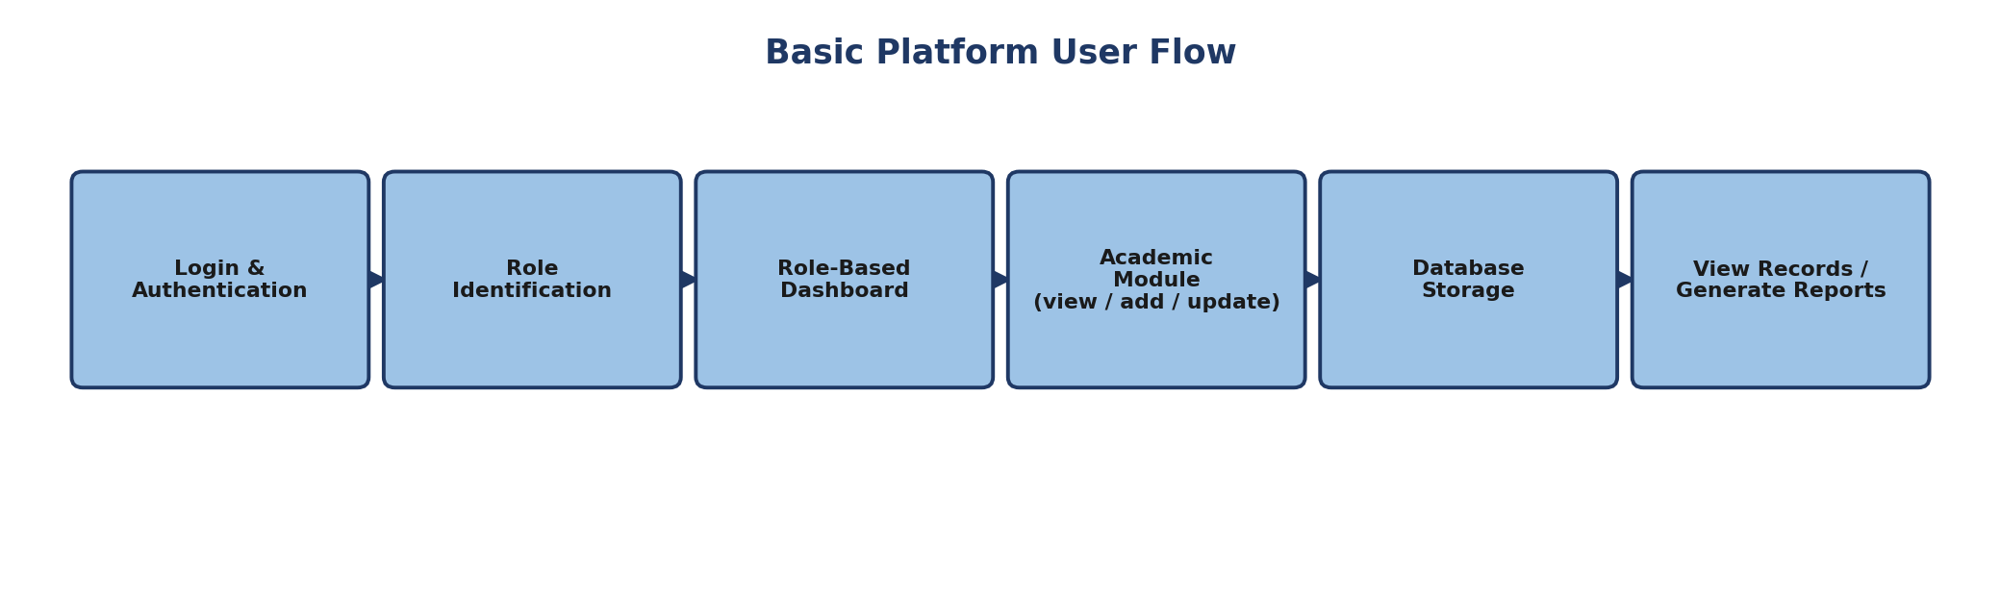

Step 3 — Initial UI structure. The prototype focuses on clear navigation, a simple dashboard structure, role-specific menus, organized academic information, easy access to important records, clear data-entry forms, and search/filtering facilities.

Step 4 — Prototype validation. The prototype is reviewed against the requirements from Empathize and Define, surfacing missing features, confusing workflows and unnecessary steps before development begins.
Outcome. An initial representation of the platform’s UI, navigation, workflow and major modules, ready to be refined during testing.

8.6 Stage 5 — Test
Objective. Evaluate the prototype against the identified user problems and requirements.
Step 1 — Test scenarios
Test Scenario | Expected Outcome
Student Login | Student accesses authorized dashboard
Faculty Login | Faculty accesses faculty functions
Administrator Login | Administrator accesses management functions
Student Record Search | Required student record is displayed
Attendance Access | Authorized user can view/manage attendance
Marks Entry | Faculty/examination staff manage marks per permissions
Result Access | Authorized users can access result information
Report Generation | Academic information is presented as a report
Step 2 — Observe user interaction, focusing on whether users understand the interface, locate the information they need, and complete their task.
Step 3 — Collect feedback on interface clarity, navigation, information organization, ease of accessing records, role-based functionality, missing features and unnecessary steps.
Step 4 — Identify improvements. For example, if users struggle to locate a report, the navigation is revised; if a form has unnecessary fields, it is simplified.
Step 5 — Iterate. Testing results can send the process back to Define, Ideate or Prototype whenever changes are needed: Prototype → Test → Feedback → Improvement → Updated Prototype.
Outcome. Validation of whether the proposed solution is understandable, usable and aligned with user requirements.

8.7 Complete Design Thinking Flow
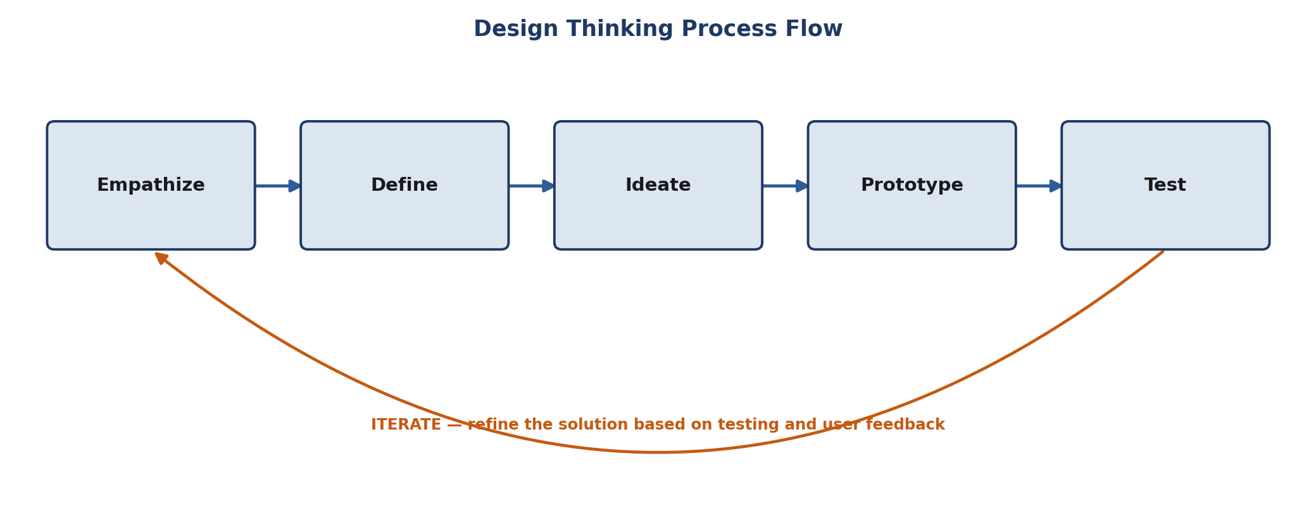
Design Thinking process flow with the iterate loop

8.8 Design Thinking Deliverables
Stage | Main Output
Empathize | Stakeholder understanding and user problems
Define | Problem statement and user needs
Ideate | Feature ideas and proposed solutions
Prototype | Initial UI, workflow and system structure
Test | Feedback, observations and improvement areas
Iterate | Refined product concept

8.9 Final Outcome
Design Thinking gives the platform a user-centered foundation. Rather than starting with code, the project identifies users, understands their problems, defines the core problem, develops possible solutions, builds an initial prototype, and validates it through testing — arriving at a clear product concept ready for requirements engineering, MVP definition, system architecture, Agile planning and implementation.

9. IBM Design Thinking Report

9.1 Introduction
IBM Design Thinking is a human-centered framework that keeps product development focused on meaningful user outcomes. It is applied here to understand user expectations, continuously improve the proposed solution, and enable different stakeholders to contribute to product development, through three principles:
- Focus on User Outcomes
- Restless Reinvention
- Diverse Empowered Teams
These principles complement the five-stage Design Thinking process used above.

9.2 Focus on User Outcomes
The first principle focuses on the outcomes users want rather than on features in isolation. The goal is not simply separate modules for attendance, examination, marks and results, but making academic information management genuinely easier and more effective for each user.
- Student outcome — clear, organized access to personal records, attendance, examination and marks information, results, and academic reports, without relying on disconnected processes.
- Faculty outcome — easier, more efficient management of attendance, marks and relevant student records.
- Administrator outcome — centralized management of student and academic information, with organized retrieval and reporting.
- Examination Cell outcome — organized management of examination information, marks, results and reports.

User | Desired Outcome
Student | Easy access to personal and academic information
Faculty | Efficient academic record management
Administrator | Centralized academic administration
Examination Cell | Organized examination and result management
The focus stays on what users should be able to achieve through the platform, not only on the technical features delivered.

9.3 Restless Reinvention
Restless Reinvention means continuously reviewing and improving the product rather than treating the first design as final. The platform is expected to evolve as new requirements, user feedback and institutional processes emerge:
User Need → Proposed Solution → Prototype → Testing → Feedback → Improvement
For example, if testing shows users struggle to find academic reports, the navigation and report-access workflow is redesigned; if administrators identify new record-management needs, those requirements feed into future iterations. Continuous improvement can come from user feedback, prototype testing, requirement refinement, interface improvements, workflow optimization and new academic-management capabilities — keeping the platform adaptable rather than fixed after its first release.

9.4 Diverse Empowered Teams
IBM Design Thinking recognizes the value of involving people with different responsibilities and perspectives. For this platform, each stakeholder group contributes a different type of requirement:

Stakeholder | Contribution
Students | User experience and academic access requirements
Faculty | Teaching and attendance workflow requirements
Academic Administrator | Administrative and student-management requirements
Examination Cell | Examination, marks and result requirements
IT Support | Technical and system-maintenance requirements
A student may spot a navigation problem an administrator would not notice; an examination staff member may surface a result-processing requirement invisible from the student’s side. Involving multiple stakeholders builds a fuller understanding of the complete academic workflow.

9.6 IBM Design Thinking Outcome
Applying IBM Design Thinking keeps the platform user-centered throughout development, connecting user outcomes with continuous improvement and stakeholder collaboration — a strong foundation for the MVP, architecture, Agile planning and implementation that follow.

10. IBM Loop Documentation

10.1 Introduction
The IBM Loop is an iterative approach of three connected activities — Observe → Reflect → Make — used to continuously learn from users, make sense of what is observed, build or improve solutions, and repeat. It is applied throughout product discovery and design so the platform evolves with user needs and feedback.
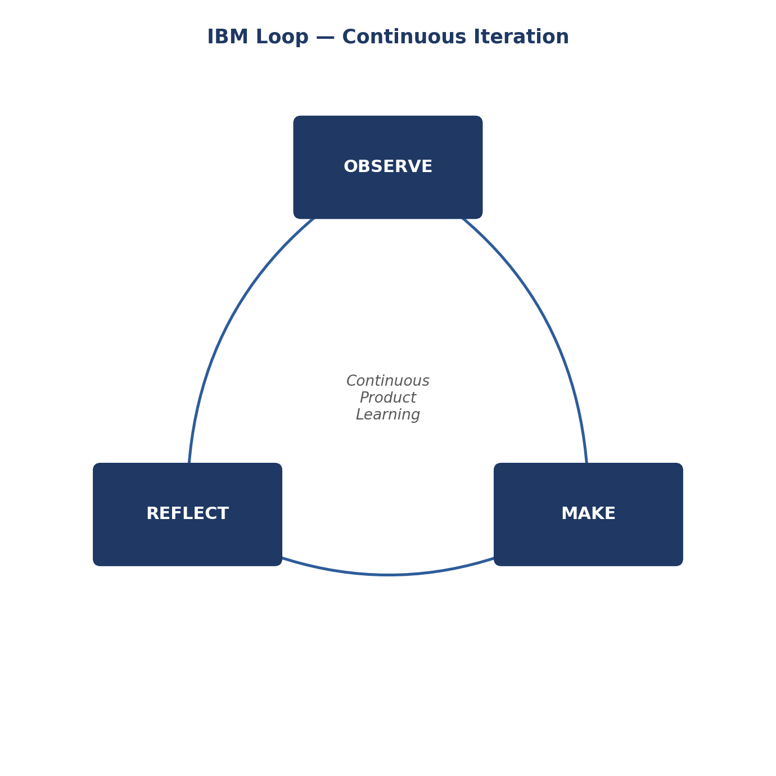
The IBM Loop — Observe, Reflect, Make

10.2 Observe
Observation focuses on student interaction with academic information, faculty record-keeping activities, administrative student-management activities, examination and result-related processes, information-access requirements, and problems in existing workflows. The key finding is a clear need for a centralized platform that organizes academic information and controls access by role — students need convenient access, while faculty, administrators and examination staff need proper management tools.
Output: a collection of user needs, observations, problems and workflow requirements.

10.3 Reflect
The observations are analyzed to identify which problems are common across users, which requirements matter most, what difficulties the platform should address, which workflows can be improved, and what features are needed to achieve the desired outcomes.
Example: Observation — students need information from different academic activities. Reflection — students need one centralized place to access that information. Product direction — a student dashboard with access to authorized academic information.
Output: a clearer understanding of user needs, product opportunities and required improvements.

10.4 Make
The Make stage turns learning and reflection into a proposed solution, prototype, or improvement — refining the interface structure, role-based dashboards, and the student management, attendance, examination, marks, result, reporting and search modules.
Initial product flow: User Login → Role Identification → Role-Based Dashboard → Required Academic Module → View / Add / Update Information → Database Storage → View Records / Generate Reports.
Output: an initial or improved representation of the product, ready for user evaluation.

10.5 IBM Loop Iteration
The loop is not a one-time sequence. After a solution is built, it is observed again and the loop continues: Observe → Reflect → Make → Observe Again → Reflect Again → Make Again — a continuous improvement cycle.

10.6 IBM Loop Applied to the Project
IBM Loop Stage | Project Activity | Output
Observe | Understand students, faculty, administrators and examination staff | User observations and problems
Reflect | Analyze requirements and identify important academic workflows | User needs and product direction
Make | Develop prototype, workflow and proposed features | Initial product solution
Observe Again | Review user interaction with the prototype | Feedback
Reflect Again | Analyze feedback | Improvement requirements
Make Again | Refine interface and functionality | Improved product

10.7 Example of the IBM Loop — Academic Reports
Observe: users need academic information in an organized format. Reflect: users need a simple way to reach relevant reports without searching through multiple modules. Make: an Academic Reports section is added. Observe Again: the prototype is reviewed to see whether users can easily find and use it. Reflect Again: if users struggle to locate reports, the navigation and dashboard structure are reconsidered. Make Again: the report section and navigation are improved.

10.8 Relationship Between Design Thinking and the IBM Loop
Design Thinking | IBM Loop
Empathize | Observe
Define | Reflect
Ideate | Reflect / Make
Prototype | Make
Test | Observe / Reflect
Iteration | Continuous Loop
Together, the two frameworks provide a structured way to understand users, develop solutions, test them and continuously improve the product.

10.9 IBM Loop Outcome
The IBM Loop provides an iterative mechanism for developing the platform. Rather than treating the first solution as final, the project continuously uses observation and feedback to refine the product:
User Observation → Learning → Product Change → User Feedback → Further Improvement
remains active throughout the development lifecycle.

10.10 Conclusion
The Observe → Reflect → Make cycle gives the project a continuous learning and improvement loop, turning user observations into meaningful product decisions and then into practical solutions — supporting continuous refinement of the interface, workflows and academic modules throughout development.

11. MVP Definition

11.1 Introduction
The Minimum Viable Product (MVP) is the initial version of the platform, containing the essential features required to provide meaningful value before advanced features are added.

11.2 MVP Objective
To provide a centralized platform for managing basic student and academic information, validating the core product concept with its intended users.

11.3 MVP Feature Scope
Feature | MVP Function
User Authentication | Secure login with role-based access
Student Management | Add, view and manage student records
Academic Management | Manage courses and academic information
Attendance Management | Record and view student attendance
Examination Management | Manage examination information
Marks Management | Enter and manage academic marks
Result Management | Generate and view student results
Academic Reports | Provide academic information in report format
Search & Filtering | Quickly locate required records

11.4 User-wise MVP Access
- Student — view profile, attendance, examination details, marks, results and reports.
- Faculty — manage attendance and relevant academic records.
- Administrator — manage students, academic information and system records.
- Examination Cell — manage examinations, marks and results.

11.5 MVP Workflow
Login → Role Identification → Dashboard → Academic Module → Manage/View Information → Database → Reports/Results

11.6 Future Scope
Advanced analytics, notifications, mobile support, automated insights and additional institutional integrations can be considered in future phases, once the MVP has been validated.

11.7 Conclusion
The MVP establishes the core functionality needed for a usable first version of the platform, providing a foundation for validating requirements and progressively expanding the system.

12. Product Roadmap

12.1 Introduction
The Product Roadmap defines the planned development phases of the platform, from product discovery and design through implementation, testing, deployment and future enhancement.

12.2 Development Roadmap
Phase | Major Activities | Expected Output
Phase 1 — Discovery | Business understanding, stakeholder analysis, user requirements | Product requirements
Phase 2 — Design | Design Thinking, personas, FRS/NFRS, UI planning | Product design
Phase 3 — Architecture | System architecture and database design | System architecture
Phase 4 — MVP Development | Authentication, student, attendance, examination, marks and result modules | Working MVP
Phase 5 — Testing | Functional, usability and system testing | Validated system
Phase 6 — Deployment | Application deployment and configuration | Deployed platform
Phase 7 — Enhancement | Feedback-based improvements and additional features | Improved product
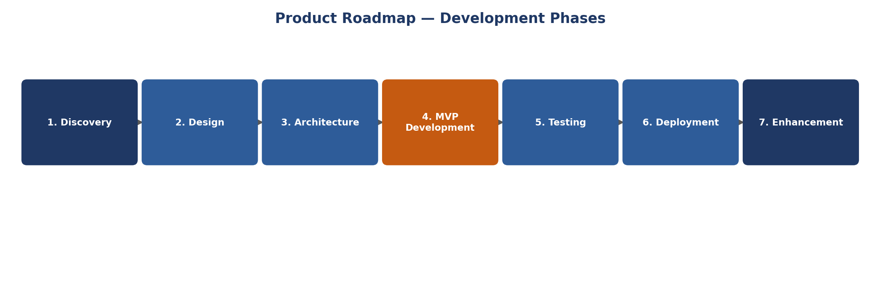
Product roadmap phase timeline

12.3 Roadmap Flow
Discovery → Design → Architecture → Development → Testing → Deployment → Continuous Improvement

12.4 Conclusion
The roadmap provides a phased path for developing the platform, ensuring implementation follows sound Product Engineering practice rather than beginning directly with coding.

13. Initial System Architecture

13.1 Introduction
The initial system architecture defines the platform’s major components and shows how users, application services and the database interact.

13.2 Architecture
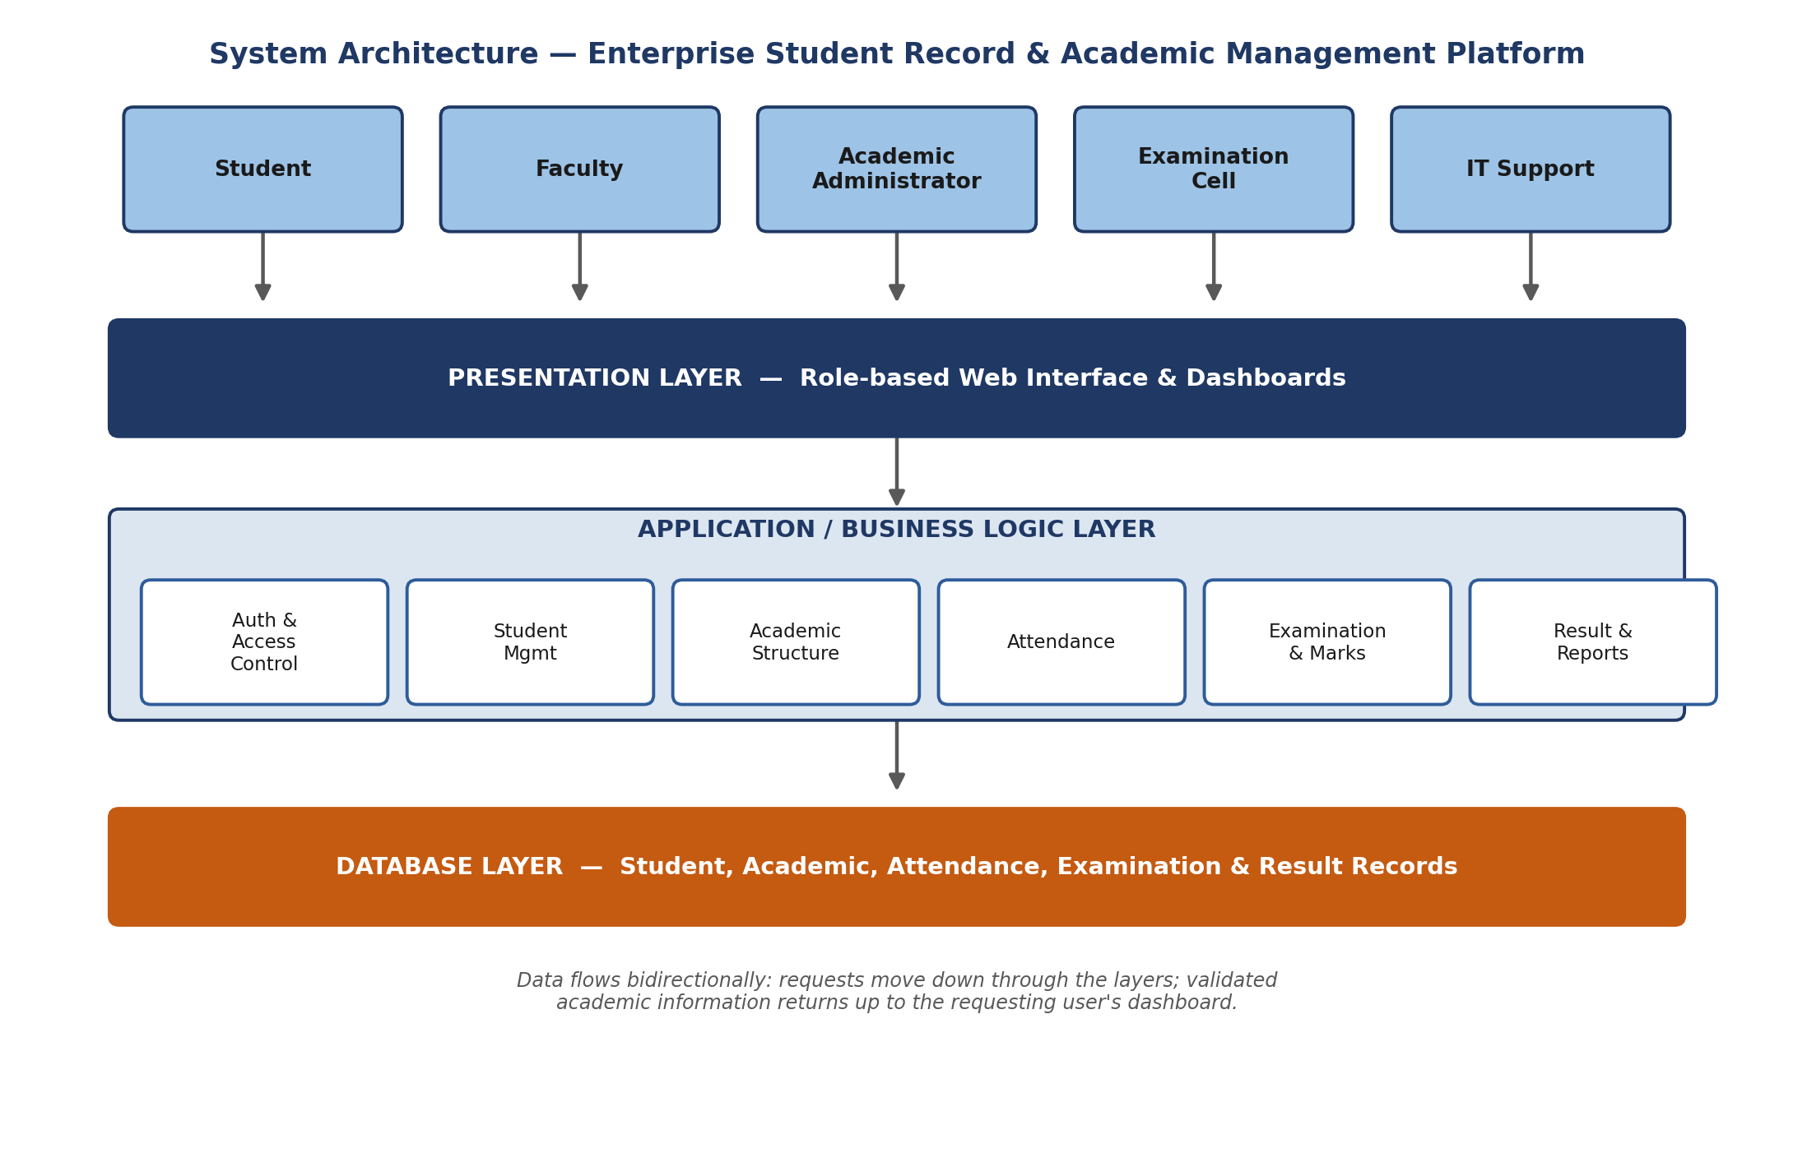
System architecture — presentation, application and database layers

13.3 Architecture Flow
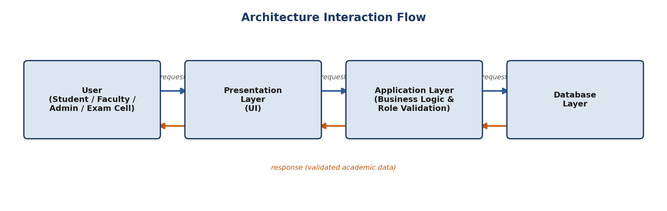
Architecture interaction flow
The user interacts with the presentation layer; the application layer processes each request according to the user’s role and the requested functionality; and the database layer stores and retrieves academic information, with validated data flowing back up to the user.

13.4 Conclusion
This initial architecture gives the platform its basic technical structure and will be refined further during detailed system architecture and implementation.

14. Project Charter

14.1 Project Overview
Project Title: Enterprise Student Record and Academic Management Platform
The project develops a centralized platform for managing student records and academic information — attendance, examinations, marks, results and academic reports.

14.2 Problem Statement
Academic information is often managed through disconnected processes and records, making it difficult to maintain, access and track efficiently. The proposed platform provides a centralized approach to academic record management.

14.3 Project Objectives
- Centralize student and academic information
- Provide role-based access to different users
- Simplify attendance, examination, marks and result management
- Provide organized academic reports
- Develop a user-friendly, maintainable platform

14.4 Project Scope
In scope: student management, user authentication, academic management, attendance management, examination management, marks management, result management, search/filtering, and academic reports.
Out of scope: mobile application, advanced AI analytics, and external institutional integrations — considered future enhancements.

14.5 Target Users
Students, Faculty, Academic Administrators and Examination Cell.

14.6 Major Deliverables
BRD, Product Vision, Stakeholder Analysis, User Personas, FRS, NFRS, Design Thinking Documentation, MVP, Product Roadmap, System Architecture, Database Design, Application, Testing Documentation, and Project Repository.

14.7 Project Phases
Project development phases

14.8 Key Risks
Risk | Mitigation
Changing requirements | Regular requirement review
Data security issues | Authentication and role-based access
Technical problems | Testing and iterative development
Data inconsistency | Validation and database constraints

14.9 Expected Outcome
A functional, user-friendly Enterprise Student Record and Academic Management Platform providing centralized, secure and organized management of student academic information.

15. Product Discovery Documentation

15.1 Introduction
Product Discovery is the phase in which the team studies the business problem, understands the users, identifies requirements, explores possible solutions and defines the product direction before full implementation begins. For this platform, discovery focuses on how student and academic information is managed within an institution, and the problems faced by students, faculty, administrators and examination staff — to make sure the software solves a clearly identified problem and delivers meaningful outcomes.

15.2 Business and Domain Understanding
The platform sits in the higher education academic management domain. Institutions manage student registration, course information, attendance, examinations, marks, results and academic reports — activities that involve multiple stakeholders and require accurate, accessible records:
Student Registration → Academic Information → Attendance → Examination → Marks → Results → Academic Reports
This domain understanding grounds the requirements that follow.

15.3 Problem Discovery
The major problem is that academic information is handled through disconnected processes and records, making it difficult to access, update, maintain and track. Students need convenient access to their records, while faculty and administrative staff need appropriate tools for managing them. This gives the project its core problem:
“Educational institutions require a centralized, secure and user-friendly platform to manage student records and academic information across different academic activities.”

15.4 Stakeholder Discovery
Stakeholder | Role in the System | Major Requirement
Student | Uses academic information | View profile, attendance, marks, results and reports
Faculty | Manages academic activities | Manage attendance and academic records
Academic Administrator | Manages institutional academic information | Manage students and academic records
Examination Cell | Handles examination activities | Manage examinations, marks and results
IT Support | Supports technical operation | Maintain system availability and technical functionality

15.5 User Needs Discovery
Students need simple access to personal and academic information — attendance, examination information, marks, results and reports, within their authorized access.
Faculty need an organized system for attendance and academic records that reduces manual effort and gives structured access to student information.
Administrators need centralized management of student and academic information, with the ability to maintain records and retrieve what they need for administration.
Examination Cell staff need facilities for managing examination information, marks, results and reports.

15.6 Requirement Discovery
Functional requirements: User Authentication; Role-Based Access; Student Record Management; Academic Management; Attendance Management; Examination Management; Marks Management; Result Management; Academic Report Generation; Search and Filtering.
Non-functional requirements: Security (protecting academic information from unauthorized access); Usability (a simple, user-friendly interface); Reliability (accurate, consistent records); Scalability (supporting growth in students, faculty, courses and records); Maintainability (efficient future modification and enhancement) — consistent with the Unit-1 specification’s emphasis on security, usability, reliability and scalability.

15.7 Existing Process Understanding
Before defining the solution, the academic-management workflow is considered from each stakeholder’s perspective:
Student Information → Course/Academic Information → Attendance → Examination → Marks → Result → Academic Report
Each stage produces or consumes information needed by other activities, so maintaining these records in one connected platform gives a far more organized approach than disconnected registers.

15.8 Solution Discovery
The proposed solution is a centralized Enterprise Student Record and Academic Management Platform in which different users receive access according to their responsibilities:
- Role-Based Access — students, faculty, administrators and examination staff each get appropriate functionality
- Centralized Student Records — structured rather than disconnected record-keeping
- Academic Management — institutional and student-facing academic information in one place
- Attendance Management — faculty manage attendance; authorized users access relevant records
- Examination and Marks Management — dedicated modules for examination information and marks
- Result Management — structured management of and access to student results
- Academic Reports — relevant information presented as reports for authorized users

15.9 Product Opportunity
Instead of treating student records, attendance, examination, marks and results as separate processes, the platform connects these activities through a common academic information structure — improving information accessibility, record organization and overall workflow.

15.10 MVP Discovery
The core MVP scope: Authentication → Student Management → Academic Management → Attendance → Examination → Marks → Results → Academic Reports, with advanced features considered only after the core product is validated with users — consistent with building the MVP around essential registration, record management, attendance and report functionality before expanding further.

15.11 Product Discovery Flow
Business Understanding → Problem Identification → Stakeholder Identification → User Understanding → Requirement Discovery → Solution Exploration → MVP Identification → Product Direction → System Design & Development

15.12 Discovery Outcomes
Discovery Area | Outcome
Business Understanding | Higher-education academic management domain identified
Problem Discovery | Need for centralized academic information management identified
Stakeholder Discovery | Major system users identified
User Needs | User-specific requirements identified
Requirement Discovery | Functional and non-functional requirements identified
Solution Discovery | Centralized academic management platform proposed
MVP Discovery | Core product functionality identified
Product Direction | Foundation established for architecture and development

15.13 Relationship with Further Project Phases
Product Discovery is not the end of product planning — its outcomes feed System Architecture and Database Design directly, the MVP requirements feed development planning, and user needs continue to guide Design Thinking, testing and future improvement. In this way, Product Discovery connects the business problem and user requirements to the technical development lifecycle.

16. Project Repository Initialization

16.1 Introduction
Project Repository Initialization creates and organizes a centralized version-control repository for the platform. The repository holds source code, database resources, documentation, testing resources, configuration files and other project artifacts, with Git used to track changes throughout the development lifecycle and to act as the central engineering workspace.

16.2 Repository Objective
- Create a centralized project workspace
- Maintain project documentation and technical resources
- Track changes using Git version control
- Organize source code, database, testing and documentation resources
- Provide a structured base for future development and collaboration

16.3 Repository Name
Enterprise-Student-Record-Academic-Management
This name represents the complete project and serves as the central location for both product documentation and future application implementation.

16.4 Repository Initialization Process
Step 1 — Create the project repository on GitHub under Enterprise-Student-Record-Academic-Management, intended to hold the complete project lifecycle’s artifacts.
Step 2 — Initialize the local project
git init
Step 3 — Add project files
git add .
Step 4 — Create the initial commit
git commit -m "Initial project repository setup"
Step 5 — Connect the GitHub repository
git remote add origin <GitHub-Repository-URL>
Step 6 — Push the project
git push -u origin main
After this, the project structure and initial resources are available in the remote repository.

16.5 Repository Contents
Category | Purpose
Documentation | Product and engineering documentation
Frontend | User-interface implementation
Server | Backend/application services
Database | Database schema, scripts and related resources
Tests | Testing resources and test cases
Screenshots | Project interface and implementation evidence
README.md | Project overview and setup information

16.6 Version Control Approach
Git tracks the different versions of the project as it develops, with meaningful commit messages keeping the history traceable. The repository can later support branches for development, feature implementation, testing and stable releases as the project grows.

16.7 Repository Evidence
Documentation should include: the GitHub repository homepage screenshot; repository name and visibility screenshot; initial commit screenshot; repository folder structure screenshot; and the repository URL — evidence that the repository has been initialized and maintained as part of the Product Engineering process.

16.8 Outcome
Repository initialization establishes a centralized, version-controlled workspace, providing the foundation for maintaining documentation, source code, database resources, testing artifacts and future development in an organized way.

16.9 Conclusion
The GitHub repository serves as the central project repository for the platform. Its initialization establishes version control and a structured foundation for the development, testing, documentation and deployment activities that follow.

17. Project Folder Structure

17.1 Introduction
A standardized folder structure organizes the platform’s different artifacts, making the project easier to understand, maintain, develop, test and extend. The Project Engineering Guide recommends separating application resources, database resources, tests, documentation and deployment-related resources into structured directories.

17.2 Proposed Project Structure
Enterprise-Student-Record-Academic-Management/
│
├── Documentation/
├── Frontend/
├── Server/
├── Database/
├── Tests/
├── Screenshots/
│
├── .env.example
├── .gitignore
├── app.js
├── index.html
├── package.json
├── package-lock.json
├── style.css
└── README.md

17.3 Folder Description
README.md — an overview of the project, its purpose, major technologies, setup instructions, project structure and basic usage information.
Documentation/ — all product-engineering documents created during the project lifecycle: business understanding, requirements, Design Thinking, IBM Design Thinking, MVP, roadmap, architecture, project charter and product discovery documentation.
Frontend/ — the user-interface implementation: pages, reusable components, stylesheets, JavaScript files, images and other frontend assets.
Server/ — backend and application-level resources responsible for processing requests and implementing business logic: routes, controllers, services, middleware and configuration files.
Database/ — database design and management resources: schema, sample data, stored procedures, triggers and migration scripts.
Tests/ — testing resources used to verify correctness and quality, with unit, integration and system-level testing kept separate.
Screenshots/ — project evidence: UI screenshots, database screenshots, testing outputs and other implementation evidence.

17.4 Documentation Organization
Each major documentation topic gets its own directory under Documentation/, making individual artifacts easy to locate and keep up to date, for example:
Documentation/
└── 13-System-Architecture/
├── Initial-System-Architecture.pdf
└── Architecture-Diagram.png
Documentation/
└── 08-Design-Thinking/
├── Design-Thinking-Report.pdf
└── Design-Thinking-Flow.png

17.5 Folder Structure Principles
- Separation — different project resources live in appropriate directories
- Organization — related files are grouped together
- Maintainability — developers can locate and modify resources easily
- Scalability — new modules and resources can be added without disturbing the overall structure
- Traceability — documentation, source code, database resources and testing evidence stay separately identifiable

17.6 Relationship with System Architecture
The folder structure organizes the project repository; the System Architecture describes how the software components interact at runtime. The repository organization supports the architecture by keeping frontend, server, database, testing and documentation resources separately maintained.

17.7 Expected Outcome
A clean, scalable repository for the complete project, supporting the move from product planning to implementation while keeping documentation, application code, database resources and testing artifacts clearly separated.

17.8 Conclusion
The Enterprise Student Record and Academic Management Platform uses a structured repository organization to support professional Product Engineering practice. The proposed folder structure keeps documentation, frontend, backend/server, database, testing and project evidence in clearly defined locations — making the repository easier to understand, maintain, collaborate on and extend through future development phases.

18. Conclusion
This documentation has taken the Enterprise Student Record and Academic Management Platform through the complete early product-engineering lifecycle — from understanding the business problem to defining the technical and organizational foundation needed to begin implementation.
The Business Problem Statement, BRD and Product Vision established why the platform is needed: academic information in most institutions is scattered across registers, spreadsheets and manual processes, and a centralized platform is the most direct way to fix that. The Stakeholder Analysis and User Personas grounded the project in the people who will actually use it — students, faculty, academic administrators, examination cell staff and IT support — each with distinct goals, responsibilities and access needs. The FRS and NFRS translated those needs into concrete functional and quality requirements, while the Design Thinking, IBM Design Thinking and IBM Loop exercises ensured the solution stayed user-centered and open to continuous refinement rather than being fixed after a single design pass.
From there, the MVP Definition and Product Roadmap scoped a realistic first release and sequenced the work into manageable phases, the Initial System Architecture defined how the platform’s layers will interact, and the Project Charter, Product Discovery, Repository Initialization and Folder Structure put the organizational and technical scaffolding in place for development to begin in an orderly, traceable way.
Taken together, these documents show a consistent thread: every stakeholder should be able to reach the academic information relevant to them, securely and without unnecessary friction, through a single centralized platform rather than fragmented records. That principle — centralized, role-based, reliable access to academic information — is the foundation the subsequent phases of development, testing and deployment will build on.
The immediate next steps are to carry this documentation into detailed database design and system architecture, begin MVP development against the scope defined in Section 11, and validate each module against the personas and success criteria defined here as implementation progresses.

